**BANGABANDHU SHEIKH MUJIBUR RAHMAN SCIENCE AND TECHNOLOGY UNIVERSITY**



**Project Report On HOME-FTP**

**Course Code: CSE278**

**Course Title: Project**

|  |  |
| --- | --- |
| **Submitted By** | **Submitted To** |
| **Yeasin Arafat- 18ICTCSE003**  **Roksana Akter -18ICTCSE004**  **Year:** 2nd  **Semester:** 2nd  Department of CSE, BSMRSTU | **Dr. Saleh Ahmed**  **Associate Professor**  Department of CSE, BSMRSTU |

## Contents

Introduction: 3

Objectives: 3

Technologies Used: 3

System Architecture: 3

Server: 3

Clients: 3

Implementation Details: 3

Server-side: 3

Client-side: 4

Features: 4

File Share: 4

File Receive: 4

Host Management: 4

Settings: 4

USE CASE DIAGRAM: 4

User Interface of Home FTP: 4

Home Page: 5

File Sharing Page: 5

Host Management Page: 6

Server Page: 7

7

Conclusion: 7

References: 7

# Introduction:

The purpose of **“Home FTP”** project is to develop a LAN-based file sharing application using Java Socket Programming. The application enables users on the same local area network (LAN) to share files seamlessly and securely. The project utilizes the client-server architecture to facilitate the transfer of files between multiple clients connected to a central server.

# Objectives:

* Enable file sharing between clients connected to the same LAN.
* Implement a secure and reliable file transfer mechanism.
* Provide a user-friendly interface for selecting and transferring files.
* Support concurrent connections from multiple clients.
* Implement basic error handling and data validation.
* Ensure efficient data transfer and minimize latency.

# Technologies Used:

* Java: Programming language for application development.
* Socket Programming: API for network communication.
* Java Swing: Library for building the graphical user interface.

# System Architecture:

The system architecture consists of two main components: the server and the clients.

## Server:

* Accepts incoming connections from multiple clients.
* Manages the file sharing requests and transfers.
* Handles authentication and authorization of clients.
* Facilitates the transfer of files between clients.

## Clients:

* Connect to the server to initiate file sharing.
* Authenticate with the server using a username and password.
* Browse and select files for sharing.
* Upload files to the server or download files from other clients.

# Implementation Details:

## Server-side:

* Set up a server socket to listen for incoming connections.
* Maintain a list of connected clients and handle concurrent connections.
* Authenticate clients using username and password verification.
* Implement file transfer functionality using input/output streams.
* Implement multi-threading to handle multiple file transfer requests.

## Client-side:

* Establish a socket connection with the server.
* Implement user authentication using a login screen.
* Display the list of connected clients and available files.
* Allow clients to browse, select, and upload/download files.
* Show the progress of file transfers and handle any errors.

# Features:

## File Share:

* Public Share: Allows users to share files publicly with all connected clients on the LAN.
* Private Share (Peer-to-Peer): Enables users to share files directly with specific clients on the LAN.

## File Receive:

* Download from FTP: Provides the capability to download files from an FTP server.
* User Management: Allows the system administrator to manage user accounts, including data providers and registered users.

## Host Management:

* Add New Host: Allows the system administrator to add new hosts or devices to the LAN.
* Delete Existing Host: Provides the ability to remove existing hosts or devices from the LAN.

## Settings:

* Profile Name Modification: Allows users to modify their profile names or usernames.
* File Path Modification: Enables users to modify the default file path for file storage or sharing.

# Use Case Diagram:

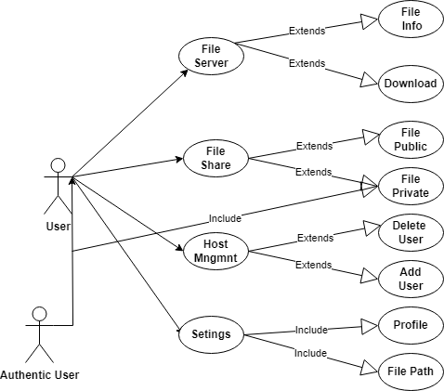

Figure 1:Use Case Diagram OF Home FTP

## 

# User Interface of Home FTP:

## Home Page:

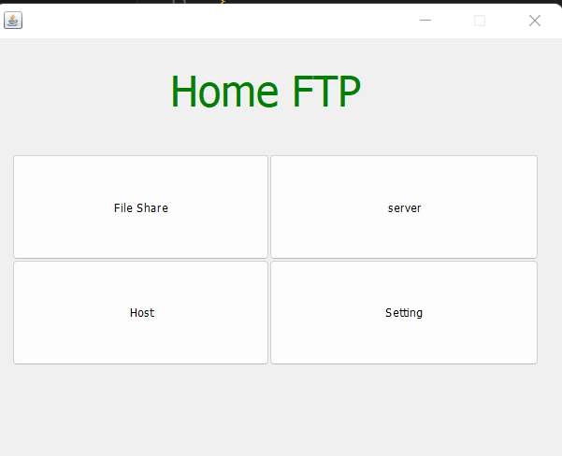

Figure 2:"Home FTP" Home Page

## File Sharing Page:

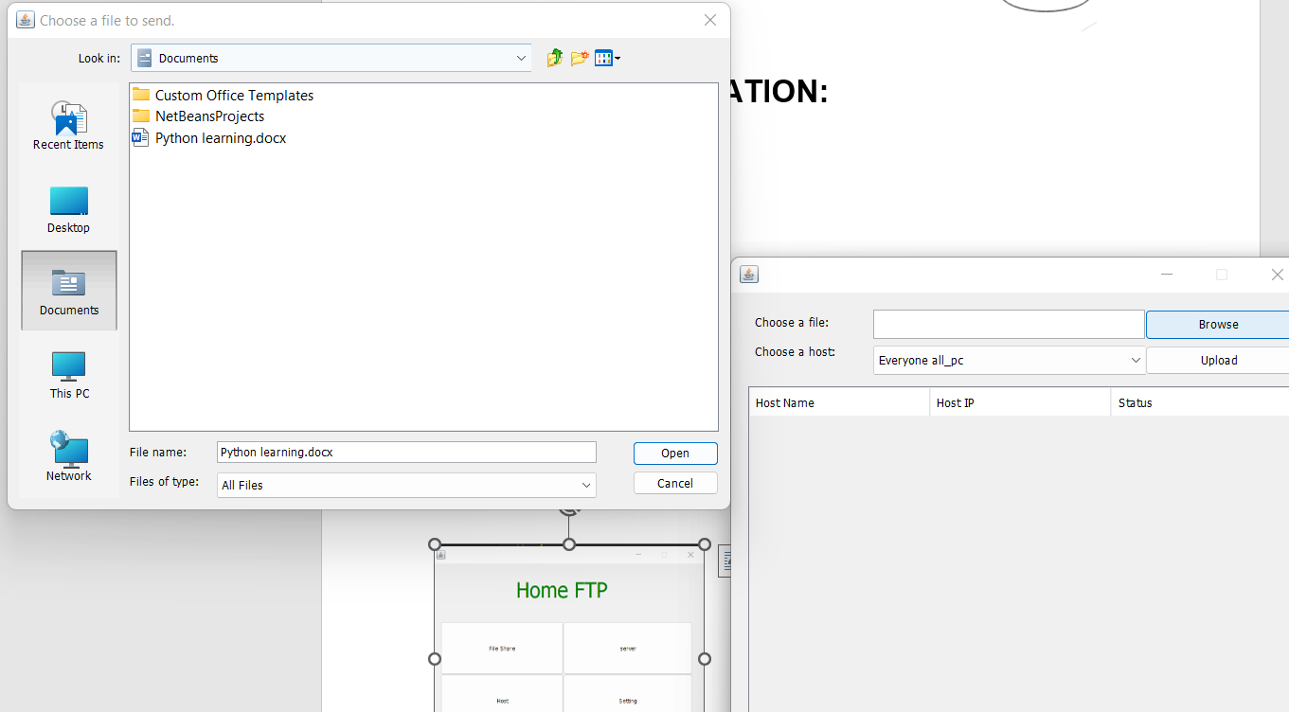

Figure 3:File sharing Page Of File Selected

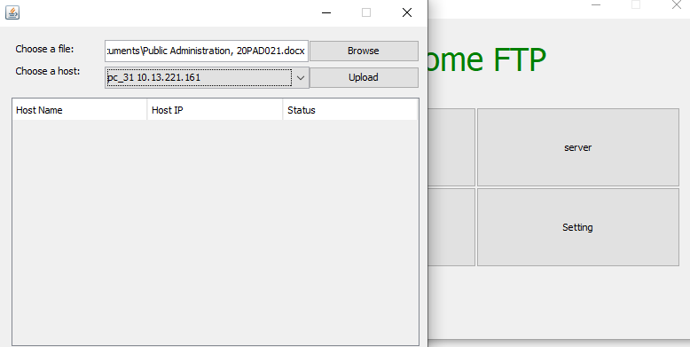

Figure 4:File Sharing Page

## Host Management Page:

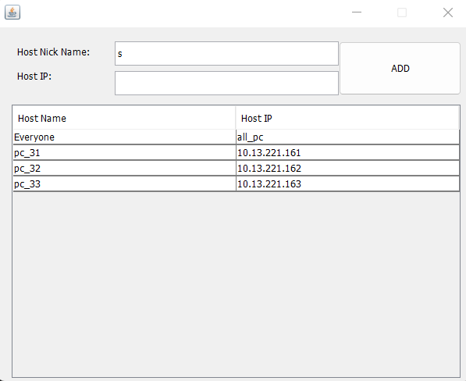

Figure 5:Host Management Page

## Server Page:

# 

Figure 6:Server Page

# Conclusion:

The LAN-based file sharing application developed using Java Socket Programming provides a reliable and secure platform for sharing files within a local area network. The client-server architecture allows for concurrent connections and efficient file transfers. The application offers a user-friendly interface, ensuring a seamless experience for users. Future enhancements could include additional security features, such as encryption, and the implementation of a more robust error handling mechanism.

# References:

Oracle Java Documentation: <https://docs.oracle.com/en/java/>

Java Socket Programming Tutorial: <https://www.javatpoint.com/socket-programming>